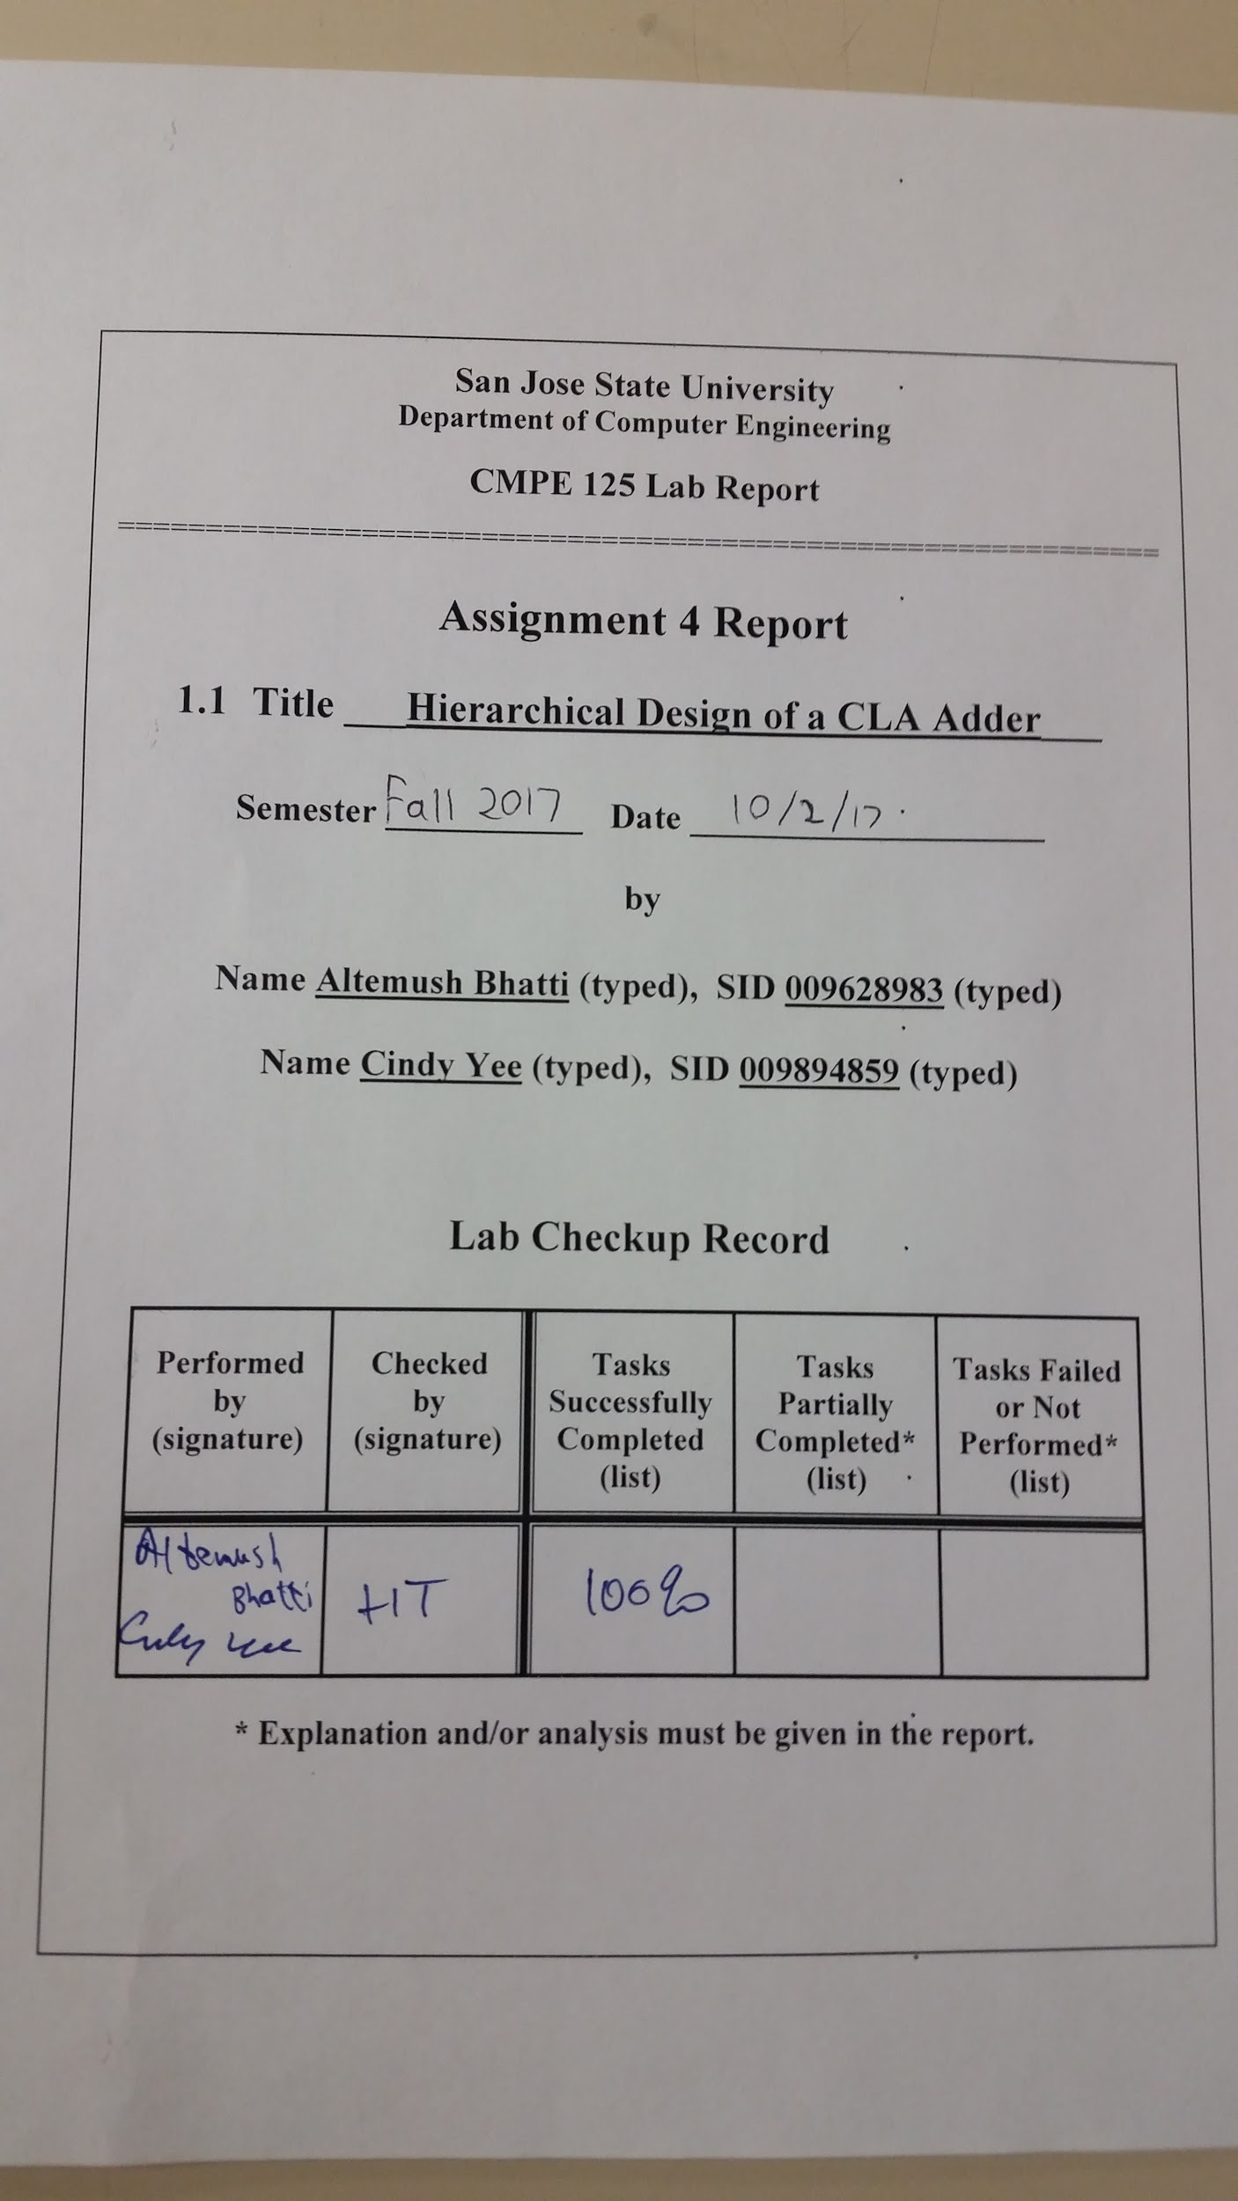

**Introduction**

The purpose of this lab was to become familiar with hierarchical and structured design methodology and with the design/verification/validation flow and Engineering Design Automation tools. During this lab, we also familiarized ourselves further with Vivado and Verilog. In this lab we designed an unsigned 4-bit inferred adder and an unsigned 4-bit carry-look-ahead adder. The inferred adder was directly inferred by the Verilog operator ‘+’ in the function-level description. The carry-look adder was designed using half adders, a custom-designed carry-look-ahead generator, and XOR gates. For both the inferred and carry-look-ahead adders, self-checking testbenches were written for simulating each one. Finally, the carry-look-ahead adder was implemented on the Nexys4 DDR FPGA board.

**Design Methodology**

The 4-bit carry-look-ahead adder is made up of four 2-bit half adders, a carry-look-ahead generator, and four 2-input XOR gates. The carry-look-ahead adder takes in two 4-bit numbers as the input, which are the inputs of the half adders. The outputs of the half adders are a sum and carry out of the inputs. These outputs can be expressed with the following equations, with *a* and *b* as the inputs of the half-adders, *p* as the sum, and *g* as the carry out:

$p=a_{i} XOR b_{i}$

$g_{i}=a_{i}*b_{i}$

*Table 1*: Truth table of half adder

|  |  |  |  |
| --- | --- | --- | --- |
| a | b | p | g |
| 0 | 0 | 0 | 0 |
| 0 | 1 | 1 | 0 |
| 1 | 0 | 1 | 0 |
| 1 | 1 | 0 | 1 |

The value *g* and a carry-in bitare the inputs of the carry-look-ahead generator. The carry-look-ahead generator can be described using the following equation:

$c_{i+1}=g_{i}+p_{i}c_{i}$

These values, along with the values of *p*, are used as the inputs of the XOR gates. The sum of the carry-look-ahead adder are the outputs of these gates, which can be seen from the following equation, with *s* as the sum of the CLA adder, *c* as the carry out values from the carry-look-ahead generator, and *p* from the half-adders:

$s_{i}=p_{i} XOR c_{i}$

*Table 2*: Truth table for XOR gate

|  |  |  |
| --- | --- | --- |
| p | c | s |
| 0 | 0 | 0 |
| 0 | 1 | 1 |
| 1 | 0 | 1 |
| 1 | 1 | 0 |

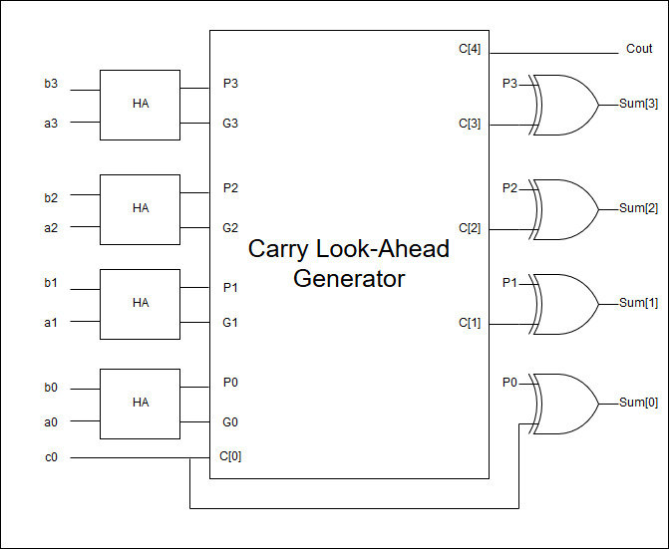

*Figure 1*: Carry look-ahead adder with half adders, carry look-ahead generator, and XOR gates.

The carry look-ahead adder could be verified by comparing the results to the inferred adder. Table three describes all the different modules created and used for this lab.

*Table 3*: List of modules used in the Lab

|  |  |
| --- | --- |
| Module Name | Description |
| *inferred_adder.v* | design source for the inferred adder |
| *inferred_adder_tb.v* | testbench for the inferred adder |
| *CLA_adder.v* | design code for the Carry Look-Ahead adder |
| *CLA_adder_tb.v* | testbench for the Carry Look-Ahead adder |
| File *clk_gen.v* | utility module to generate the clock |
| File *bcd_to_7seg.v* | utility module to display LEDs on 7-seg |
| File *led_mux.v* | utility module to select what goes to which 7-seg |
| File *CLA_adder_fpga.v* | top-level module for the CLA adder |
| *CLA_adder_fpga.xdc* | constraint file for the *CLA_adder_fpga.v* |

**Simulation Results**

The testbench for the inferred adder ran correctly with no errors, as shown in figure two. An image of the full waveforms of all inputs and outputs were included so that readers would get an idea of the magnitude of the number of changes in the inputs and outputs. A message was also included to display the simulation completion.

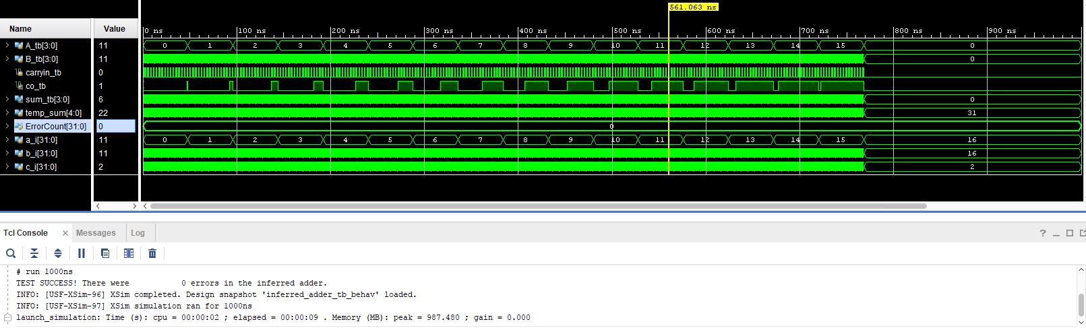

*Figure 2:* Full waveform of the *inferred_adder_tb.v* testbench with Self-checking displayed

To further examine the testbench for the inferred adder, a zoomed in version of the waveforms were included in figure three. This zoomed in version allows us to eyeball test the simulation results to see if the outputs match our expectations. In this case, the marker is at a position where inputs *A_tb*=11, *B_tb*=6, and the *carryin_tb*=1, which means that the decimal addition sum result would be equal to 18. However, the sum only has four bits which can represent 0-F in hexadecimal with F representing 15 in decimal. To solve this problem, an extra carry out bit *co_tb* which is equal to the value of 16 was included. In this case, the *sum_tb* was equal to 2 and the carry out was active, which means that the sum is 2+16=18. The results of the simulation were correct. A five bit *temp_sum* output which includes the required four bits of sum and the carry out were also included for comparison purposes.

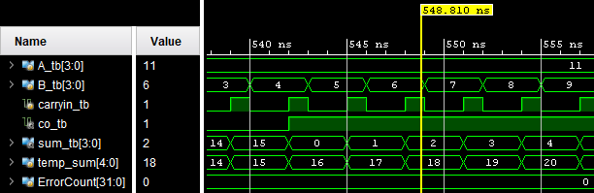

*Figure 3*: A close-up loop at the *inferred_adder_tb.v* testbench waveforms

The testbench for the CLA adder ran correctly with no errors, as shown in figure four. An image of the full waveforms of all inputs and outputs were included so that readers would get an idea of the magnitude of the number of changes in the inputs and outputs. A console message was included to display a successful self-checking test.

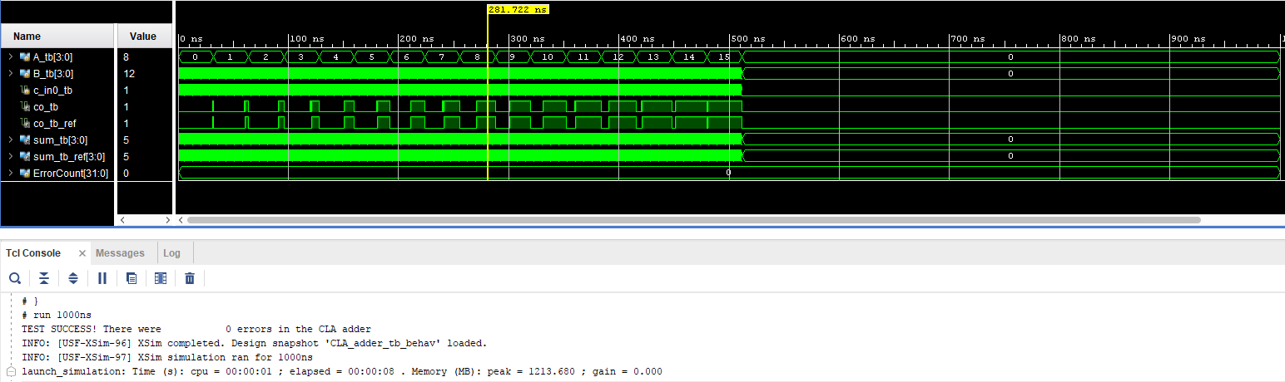

*Figure 4:* Full waveform of the *CLA_adder_tb.v* testbench with Self-checking displayed

A zoomed in version of the CLA adder simulation was included as figure five so that eyeball testing could be performed like the inferred adder above. In this example, the inputs *A_tb*=8, *B_tb*=12, and *c_in0_tb*=1 all add up to a sum of 21. The carry out bit *co_tb* was active and *sum_tb=5*, which means that the resulting sum was 16+5 which is also equal to 21. An extra confirmation was included in the reference outputs *co_tb_ref* and *sum_tb_ref* created using the inferred adder by comparing them to the CLA outputs.

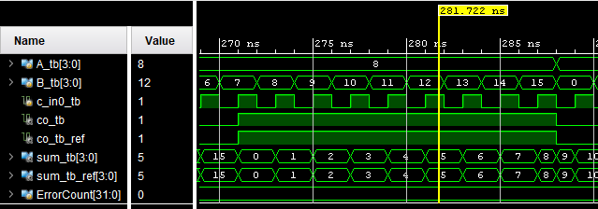

*Figure 5*: A close-up look at the *CLA_adder_tb.v* testbench waveforms

**FPGA Validation**

The validation testing for the carry look-ahead adder was completed by eyeball testing the outputs shown in the seven segment display with respect to the changing inputs from the switches *A* and *B* and the button *CarryIn0.* An extra seven segment LED was used to display whether or not there was a carry out bit that was active. In figure 6, all the switches representing the bits of *A* and all the switches representing the bits of *B* in addition to the button representing *CarryIn0* were active, which means *A*=15, *B*=15, and the *CarryIn0*=1*.* The total sum is 31, which is displayed in the seven segment display. From eyeball testing, we can verify that the results match our expectations.

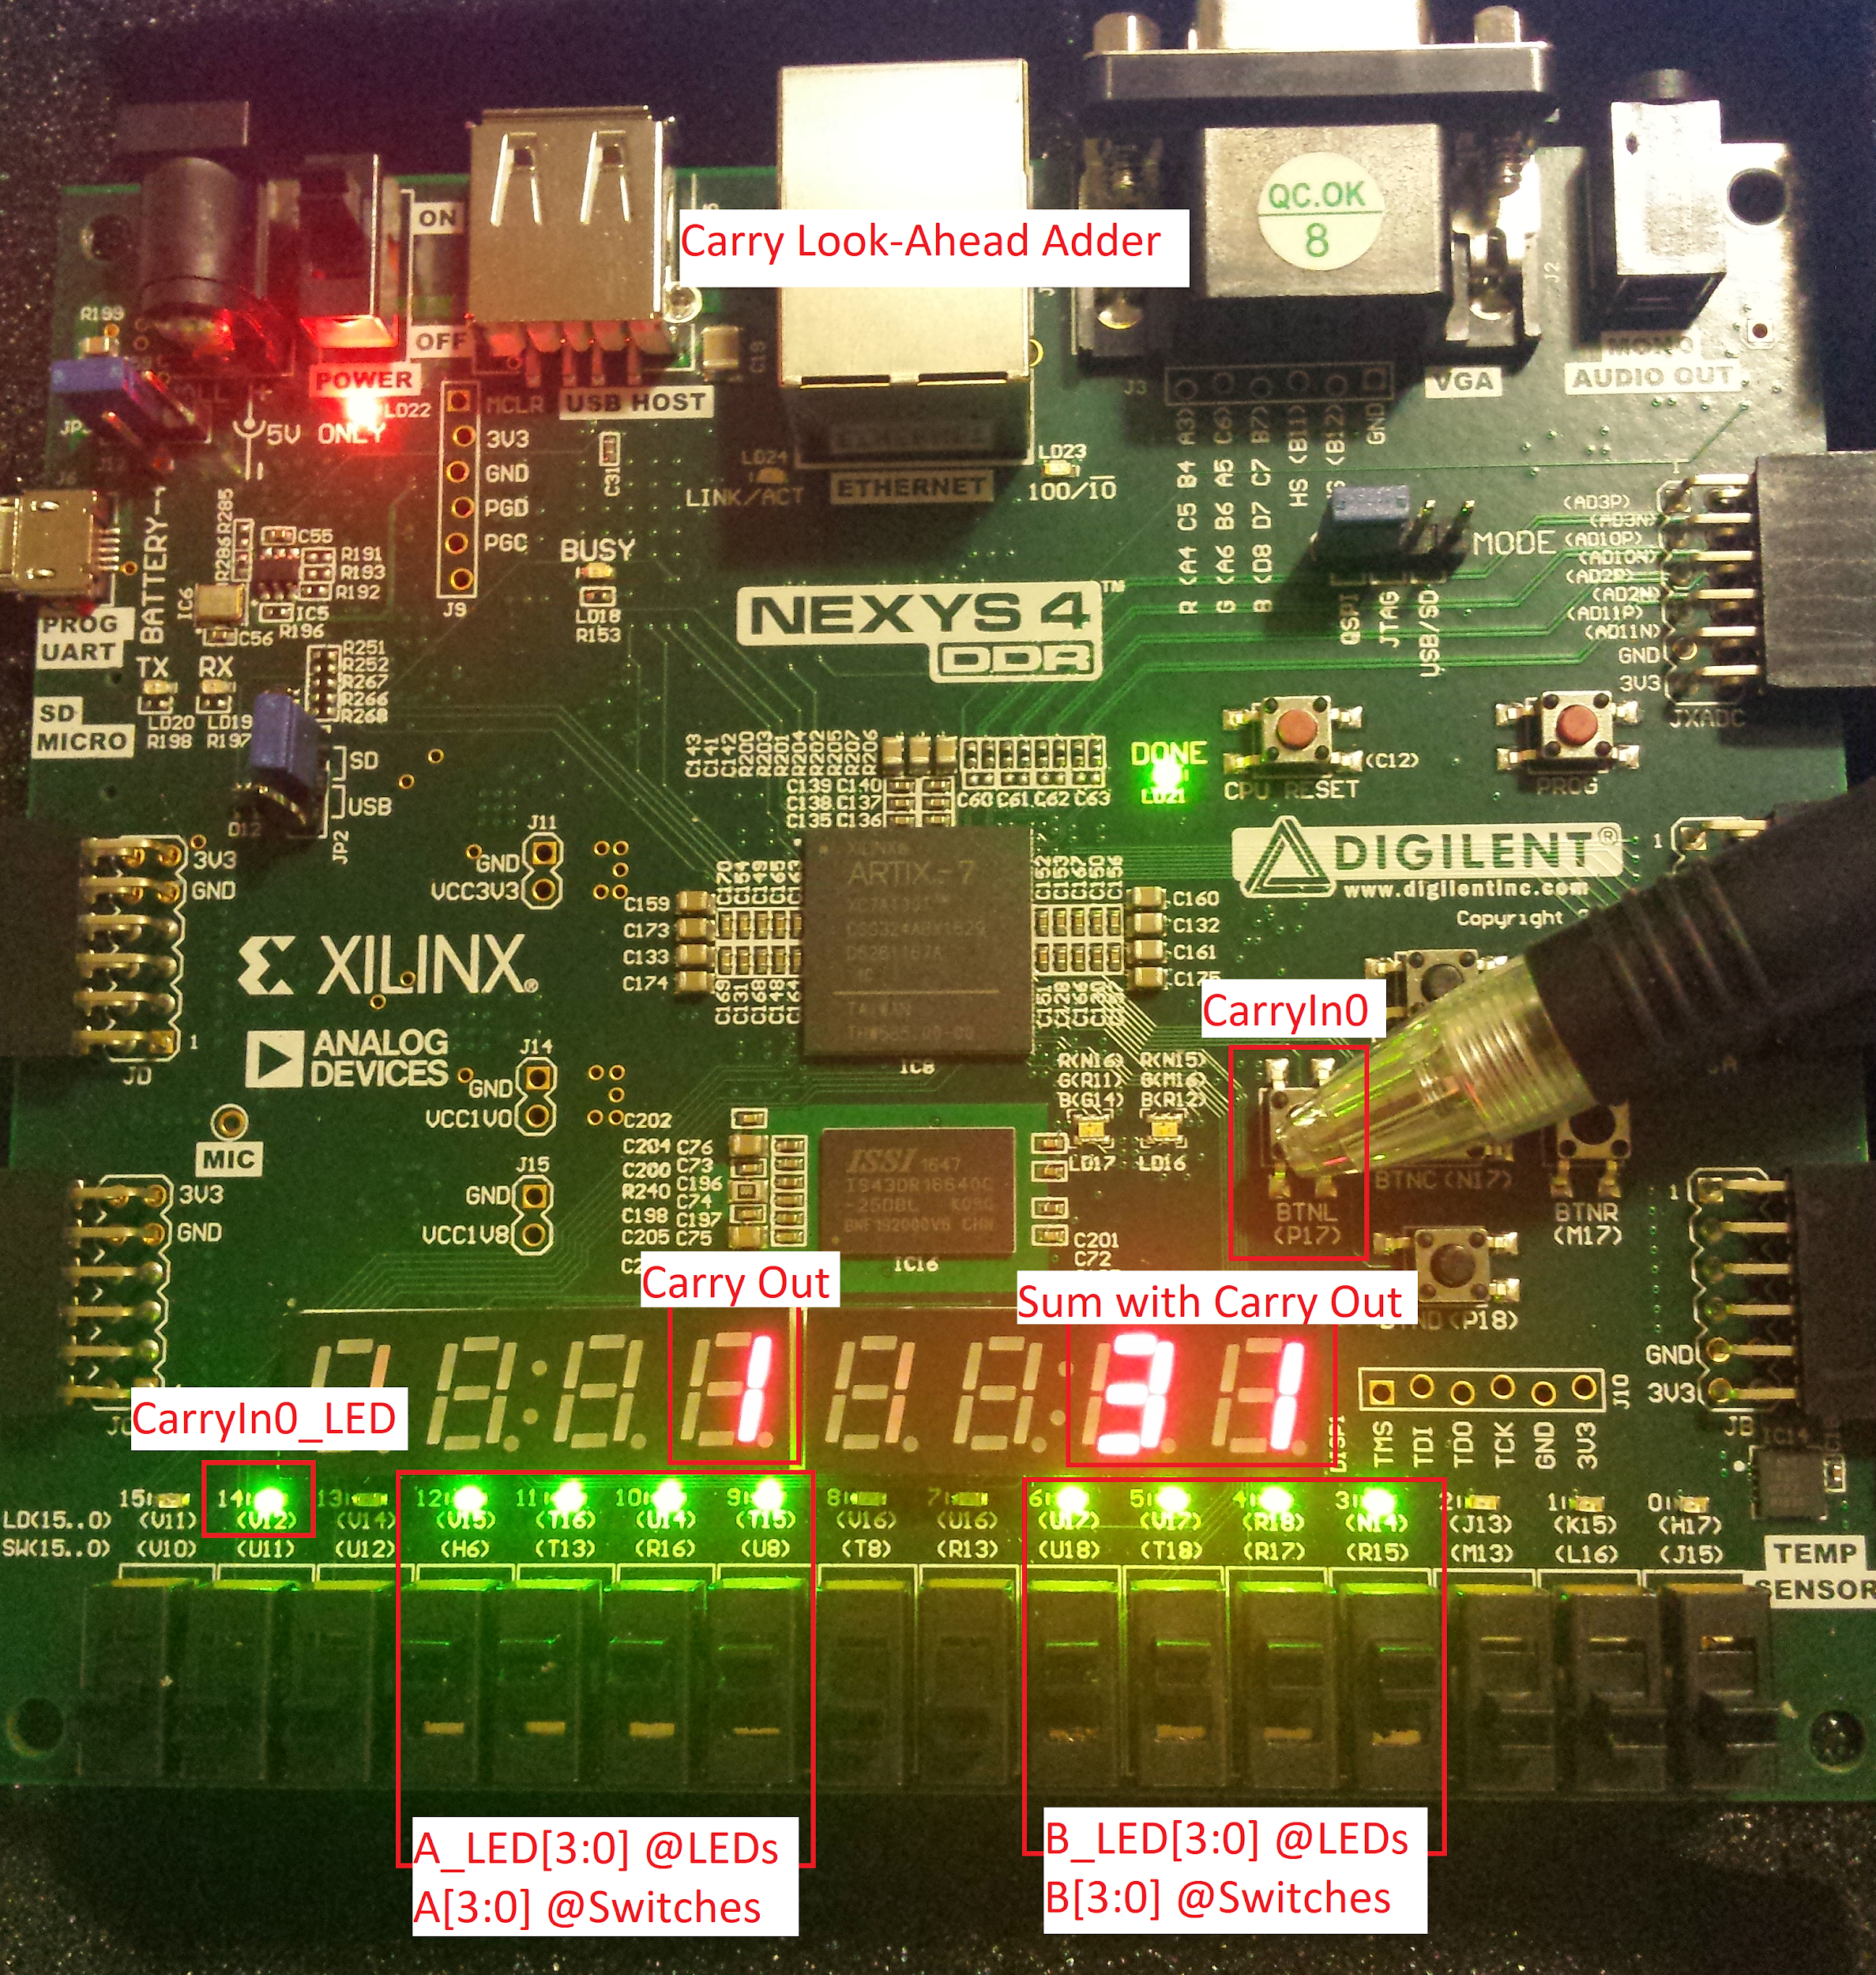

*Figure 6*: FPGA board of CLA adder validation with inputs and outputs labeled

**Conclusion**

All of the tasks were successfully completed for this lab.

The design source for the inferred adder and the simulation source with the self-checking testbench for the inferred adder was tested and verified by eyeball testing and the self checking messages.

The design source for the CLA adder was completed with the required half adder modules and XOR operators to create a hierarchical carry look-ahead adder design. The self-checking testbench successfully checked all the possible inputs of the design and returned no error messages.

The CLA adder was also successfully validated using the Nexys4 DDR board using the switches and buttons as inputs and the LEDs and outputs.

**Appendix**

1. **File *inferred_adder.v* - design source for the inferred adder**

`timescale 1ns / 1ps

module inferred_adder(input carryin, input [3:0]A, input [3:0]B,

output reg carry_out, output reg [3:0] sum );

always@(carryin,A,B)

begin

{carry_out,sum} = A + B + carryin; //We can add more than 2 Ops!

end//end always;

endmodule

1. **File *inferred_adder_tb.v* - testbench for the inferred adder**

`timescale 1ns / 1ps

module inferred_adder_tb();

reg [3:0] A_tb;

reg [3:0] B_tb;

reg carryin_tb;

wire co_tb;

wire [3:0] sum_tb;

integer a_i, b_i, c_i; //incrementers for for-loops\

reg [4:0] temp_sum;

integer ErrorCount;

inferred_adder DUT(.carryin(carryin_tb), .A(A_tb),.B(B_tb),.carry_out(co_tb), .sum(sum_tb));

initial begin

ErrorCount=0;

for(a_i=0; a_i<16; a_i=a_i+1) //4bits ----> 2^4=16

begin

assign A_tb=a_i;

for(b_i=0; b_i<16; b_i=b_i+1) //4bits --->2^4=16

begin

assign B_tb=b_i; #1;//DO NOT MAKE #0

for(c_i=0; c_i<2; c_i=c_i+1)

begin

assign carryin_tb=c_i; #1;

temp_sum=0;//clear temp_sum

temp_sum = A_tb + B_tb + carryin_tb; //temp_sum is 5 bits. sum_tb is 4 bits

if(temp_sum!=={co_tb,sum_tb})

begin

$display("Error at input A=%d B=%d at time=%d",A_tb,B_tb,$time);

ErrorCount=ErrorCount+1;

end//end if

end//end c_i

end//end b_i

end//end a_i

$display("TEST SUCCESS! There were %d errors in the inferred adder.",ErrorCount);

end//end initial

endmodule

1. **File *CLA_adder.v* - design code for the Carry Look-Ahead adder**

`timescale 1ns / 1ps

module CLA_adder(input CarryIn0, input [3:0]A, input [3:0]B, output carry_out, output [3:0] Sum);

reg c_o,c_i; //carry out and in

reg i;//increment

wire [4:0] carry_in;

wire [3:0] g_cin;

wire [3:0] p_sum;

assign carry_in[0]=CarryIn0;

half_adder HA_1 (.a(A[0]), .b(B[0]), .g(g_cin[0]), .p(p_sum[0]) );

//p_i=a_i XOR b_i //g_i=a_i AND b_i

assign carry_in[1]=g_cin[0]+(carry_in[0]&p_sum[0]); //c_i+1=g_i + p_ic_i

assign Sum[0]=(carry_in[0]^ p_sum[0]); //s_i= p_i XOR c_i

half_adder HA_2 (.a(A[1]), .b(B[1]), .g(g_cin[1]), .p(p_sum[1]) );

assign carry_in[2]=g_cin[1]+(carry_in[1]&p_sum[1]);

assign Sum[1]=(carry_in[1]^ p_sum[1]);

half_adder HA_3 (.a(A[2]), .b(B[2]), .g(g_cin[2]), .p(p_sum[2]) );

assign carry_in[3]=g_cin[2]+(carry_in[2]&p_sum[2]);

assign Sum[2]=(carry_in[2]^ p_sum[2]);

half_adder HA_4 (.a(A[3]), .b(B[3]), .g(g_cin[3]), .p(p_sum[3]) );

assign carry_in[4]=g_cin[3]+(carry_in[3]&p_sum[3]);

assign Sum[3]=(carry_in[3]^ p_sum[3]);

assign carry_out=carry_in[4];

endmodule

1. **File *CLA_adder_tb.v* - testbench for the Carry Look-Ahead adder**

`timescale 1ns / 1ps

module CLA_adder_tb();

reg [3:0] A_tb;

reg [3:0] B_tb;

reg c_in0_tb;

wire co_tb;

wire co_tb_ref;

wire [3:0] sum_tb;

wire [3:0] sum_tb_ref;

integer a_i, b_i,c_i; //incrementers

integer ErrorCount;

CLA_adder DUT_CLA(.CarryIn0(c_in0_tb), .A(A_tb),.B(B_tb),.carry_out(co_tb), .Sum(sum_tb));

inferred_adder DUT_inferred(.carryin(c_in0_tb), .A(A_tb),.B(B_tb),

.carry_out(co_tb_ref), .sum(sum_tb_ref));

initial begin

ErrorCount=0;

for(a_i=0; a_i<16; a_i=a_i+1) //4bits ----> 2^4=16

begin

assign A_tb=a_i;

for(b_i=0; b_i<16; b_i=b_i+1) //4bits --->2^4=16

begin

assign B_tb=b_i; //#2;

for(c_i=0; c_i<2; c_i=c_i+1)

begin

assign c_in0_tb=c_i; #1;

if(sum_tb_ref!==sum_tb || co_tb!==co_tb_ref)

begin

$display("Error at A=%b B=%b CLA_sum=%b and Inf_sum=%b at time=%d", A_tb,B_tb,sum_tb,sum_tb_ref,$time);

ErrorCount=ErrorCount+1;

end//end if

end//end c_i

end//end b_i

end//end a_i

$display("TEST SUCCESS! There were %d errors in the CLA adder",ErrorCount);

end//end initial

endmodule

1. **File *clk_gen.v* - utility module to generate the clock**

module clk_gen (input clk100MHz, rst,

output reg clk_4sec, clk_5KHz);

integer count1, count2;

always @ (posedge clk100MHz)

begin

if (rst)

begin

count1 = 0; clk_4sec = 0;

count2 = 0; clk_5KHz = 0;

end

else

begin

if (count1 == 200000000)

begin

clk_4sec = ~clk_4sec;

count1 = 0;

end

if (count2 == 10000)

begin

clk_5KHz = ~clk_5KHz;

count2 = 0;

end//endif

count1 = count1 + 1;

count2 = count2 + 1;

end

end//end always

endmodule

1. **File *bcd_to_7seg.v* - utility module to display LEDs on 7-seg**

module bcd_to_7seg (input c_o, input [3:0] BCD,

output reg [7:0] carryout, output reg [7:0] s_10s, output reg [7:0] s_1s);

reg [7:0] s;

reg[4:0] wCarryOut;

integer digit_10s;

integer digit_1s;

always @ (c_o,BCD)

begin

wCarryOut={c_o,BCD}; //if want to include carry out in sum(5 bits)

// wCarryOut={1'b0,BCD}; //if don't want carryout in sum(4 bits)

digit_10s = wCarryOut/10;

digit_1s = wCarryOut%10;

case(c_o)

0: carryout = 8'b10001000; //active low outputs

1: carryout = 8'b11101101;

endcase

case (digit_1s)//ones place

0: s_1s = 8'b10001000; //active low outputs

1: s_1s = 8'b11101101; //s6 s5 s4 ... s0

2: s_1s = 8'b10100010;

3: s_1s = 8'b10100100; //display 3 on 7-seg

4: s_1s = 8'b11000101; //display 4 on 7-seg

5: s_1s = 8'b10010100; //display 5 on 7-seg

6: s_1s = 8'b10010000; //and so on...

7: s_1s = 8'b10101101;

8: s_1s = 8'b10000000;

9: s_1s = 8'b10000100;

default: s_1s = 8'b01111111;

endcase

case (digit_10s)//ones place

0: s_10s= 8'b10001000; //active low outputs

1: s_10s = 8'b11101101; //s6 s5 s4 ... s0

2: s_10s = 8'b10100010;

3: s_10s = 8'b10100100; //display 3 on 7-seg

4: s_10s = 8'b11000101; //display 4 on 7-seg

5: s_10s = 8'b10010100; //display 5 on 7-seg

6: s_10s = 8'b10010000; //and so on...

7: s_10s = 8'b10101101;

8: s_10s = 8'b10000000;

9: s_10s = 8'b10000100;

default: s_10s = 8'b01111111;

endcase

end

endmodule

1. **File *led_mux.v* - utility module to select what goes to which 7-seg**

`timescale 1ns / 1ps

//for multiplexing signals to be displayed on 7seg

module led_mux(input clk, rst,

input [7:0] LED7, LED6, LED5, LED4, LED3, LED2, LED1, LED0,

output [7:0] LEDSEL, LEDOUT); //which 7 seg and what digit to display

reg [2:0] index;

reg [15:0] led_ctrl;

assign {LEDSEL, LEDOUT} = led_ctrl;

always @ (posedge clk) index <= (rst) ? 3'b0 : (index + 3'd1);

always @ (index, LED0, LED1, LED2, LED3, LED4, LED5, LED6, LED7)

begin

case (index)

0: led_ctrl <= {8'b11111110, LED0};

1: led_ctrl <= {8'b11111101, LED1};

2: led_ctrl <= {8'b11111011, LED2};

3: led_ctrl <= {8'b11110111, LED3};

4: led_ctrl <= {8'b11101111, LED4};

5: led_ctrl <= {8'b11011111, LED5};

6: led_ctrl <= {8'b10111111, LED6};

7: led_ctrl <= {8'b01111111, LED7};

default: led_ctrl <= {8'b11111111, 8'hFF};

endcase

end

endmodule

1. **File *CLA_adder_fpga.v* - top-level module for the CLA adder**

`timescale 1ns / 1ps

//Top Level module

module CLA_adder_fpga(input clk100MHz, rst,

input CarryIn0, input [3:0]A, [3:0]B,

output CarryIn0_LED, output [3:0] A_LED, [3:0] B_LED, //display input

output [7:0] LEDSEL, [7:0] LEDOUT); //display sum on 7seg

supply1 [7:0] vcc;

wire DONT_USE, clk_5KHz;

wire [7:0] co_7seg, tens, ones;

wire [3:0] sum;

wire carry_out;

///*************************************//

CLA_adder DUT (CarryIn0,A,B,carry_out,sum);

//*****************************************//

clk_gen CLK (clk100MHz, rst, DONT_USE, clk_5KHz);

bcd_to_7seg BCD (carry_out,sum, co_7seg, tens, ones);

led_mux LED_ones (clk_5KHz, rst,

vcc, vcc, vcc, co_7seg, vcc,vcc, tens, ones, //activelow so vcc

LEDSEL, LEDOUT);

assign CarryIn0_LED=CarryIn0;

assign A_LED=A;

assign B_LED=B;

endmodule

1. **File *CLA_adder_fpga.xdc* - constraint file for the CLA adder**

#Clock Generator

set_property -dict {PACKAGE_PIN E3 IOSTANDARD LVCMOS33} [get_ports {clk100MHz}];

create_clock -add -name sys_clk_pin -period 10.00 -waveform {0 5} [get_ports {clk100MHz}];

set_property -dict {PACKAGE_PIN N17 IOSTANDARD LVCMOS33} [get_ports {rst}];

##Input B

set_property -dict { PACKAGE_PIN R15 IOSTANDARD LVCMOS33 } [get_ports { B[0] }]; #sw[3]

set_property -dict { PACKAGE_PIN R17 IOSTANDARD LVCMOS33 } [get_ports { B[1] }]; #sw[4]

set_property -dict { PACKAGE_PIN T18 IOSTANDARD LVCMOS33 } [get_ports { B[2] }]; #sw[5]

set_property -dict { PACKAGE_PIN U18 IOSTANDARD LVCMOS33 } [get_ports { B[3] }]; #sw[6]

#Input A

set_property -dict { PACKAGE_PIN U8 IOSTANDARD LVCMOS18 } [get_ports { A[0] }]; #sw[9]

set_property -dict { PACKAGE_PIN R16 IOSTANDARD LVCMOS33 } [get_ports { A[1] }]; #sw[10]

set_property -dict { PACKAGE_PIN T13 IOSTANDARD LVCMOS33 } [get_ports { A[2] }]; #sw[11]

set_property -dict { PACKAGE_PIN H6 IOSTANDARD LVCMOS33 } [get_ports { A[3] }]; #sw[12]

##Input Carry In

set_property -dict { PACKAGE_PIN P17 IOSTANDARD LVCMOS33 } [get_ports { CarryIn0 }]; #btnl

##Display Input B

set_property -dict { PACKAGE_PIN N14 IOSTANDARD LVCMOS33 } [get_ports {B_LED[0] }]; #\led[3]

set_property -dict { PACKAGE_PIN R18 IOSTANDARD LVCMOS33 } [get_ports {B_LED[1] }]; #led[4]

set_property -dict { PACKAGE_PIN V17 IOSTANDARD LVCMOS33 } [get_ports {B_LED[2] }]; #led[5]

set_property -dict { PACKAGE_PIN U17 IOSTANDARD LVCMOS33 } [get_ports {B_LED[3] }]; #led[6]

#Display Input A

set_property -dict { PACKAGE_PIN T15 IOSTANDARD LVCMOS33 } [get_ports { A_LED[0] }]; #led[9]

set_property -dict { PACKAGE_PIN U14 IOSTANDARD LVCMOS33 } [get_ports { A_LED[1] }]; #led[10]

set_property -dict { PACKAGE_PIN T16 IOSTANDARD LVCMOS33 } [get_ports { A_LED[2] }]; #led[11]

set_property -dict { PACKAGE_PIN V15 IOSTANDARD LVCMOS33 } [get_ports { A_LED[3] }]; #led[12]

##Display Input CarryIn0

set_property -dict { PACKAGE_PIN V12 IOSTANDARD LVCMOS33 } [get_ports { CarryIn0_LED }]; #led[14]

#Which 7-segment display to use

set_property -dict {PACKAGE_PIN J17 IOSTANDARD LVCMOS33} [get_ports {LEDSEL[0]}]; #far right

set_property -dict {PACKAGE_PIN J18 IOSTANDARD LVCMOS33} [get_ports {LEDSEL[1]}];

set_property -dict {PACKAGE_PIN T9 IOSTANDARD LVCMOS33} [get_ports {LEDSEL[2]}];

set_property -dict {PACKAGE_PIN J14 IOSTANDARD LVCMOS33} [get_ports {LEDSEL[3]}];

set_property -dict {PACKAGE_PIN P14 IOSTANDARD LVCMOS33} [get_ports {LEDSEL[4]}];

set_property -dict {PACKAGE_PIN T14 IOSTANDARD LVCMOS33} [get_ports {LEDSEL[5]}];

set_property -dict {PACKAGE_PIN K2 IOSTANDARD LVCMOS33} [get_ports {LEDSEL[6]}];

set_property -dict {PACKAGE_PIN U13 IOSTANDARD LVCMOS33} [get_ports {LEDSEL[7]}]; #far left

#What to display at the 7-seg displays ALL ACTIVE LOW

set_property -dict {PACKAGE_PIN K13 IOSTANDARD LVCMOS33} [get_ports {LEDOUT[0]}];

set_property -dict {PACKAGE_PIN K16 IOSTANDARD LVCMOS33} [get_ports {LEDOUT[1]}];

set_property -dict {PACKAGE_PIN P15 IOSTANDARD LVCMOS33} [get_ports {LEDOUT[2]}];

set_property -dict {PACKAGE_PIN L18 IOSTANDARD LVCMOS33} [get_ports {LEDOUT[3]}];

set_property -dict {PACKAGE_PIN R10 IOSTANDARD LVCMOS33} [get_ports {LEDOUT[4]}];

set_property -dict {PACKAGE_PIN T11 IOSTANDARD LVCMOS33} [get_ports {LEDOUT[5]}];

set_property -dict {PACKAGE_PIN T10 IOSTANDARD LVCMOS33} [get_ports {LEDOUT[6]}];

set_property -dict {PACKAGE_PIN H15 IOSTANDARD LVCMOS33} [get_ports {LEDOUT[7]}];